Report on Anti-Lock Breaking System

This example shows how to model a simple model for an Anti-Lock Braking System (ABS). It simulates the dynamic behaviour of a vehicle under hard braking conditions. The model represents a single wheel, which may be replicated a number of times to create a model for a multi-wheel vehicle. The model is used to demonstrate the Anti-Lock Breaking System is shown below.

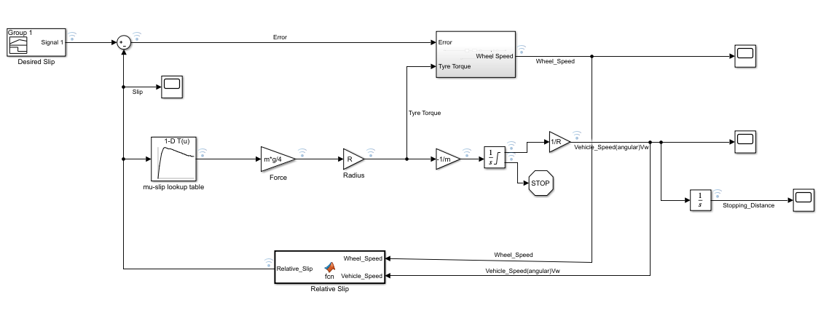

Figure 1

**Equations used:**

Actual Relative slip=1-(Wheel speed/Vehicle speed)

m= mass

g= acceleration due to gravity

R= radius of the wheel

V0= vehicle linear velocity

Force(N)=mg/4

mu=coefficient of friction

Tyre Torque=mu*N*R

Equivalent Vehicle Angular acceleration=(-Tyre Torque)/(vehicle mass* Wheel Radius) (- for deceleration)

Equivalent vehicle Angular velocity= Integral of equivalent angular acceleration

NOTE: F=ma, T=Fr=ma*r, a=T/(m*r), v=∫a dt

## Calculation of wheel speed for ABS

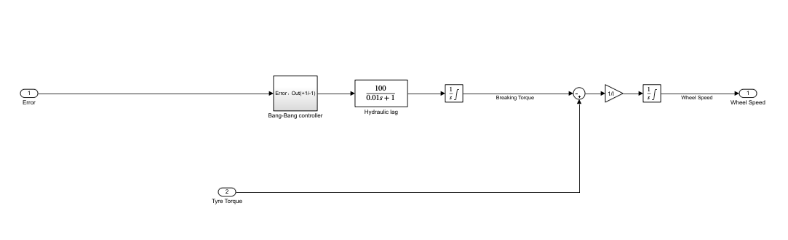

The brake torque is subtracted to give the net torque on the wheel. Dividing the net torque by the wheel rotational inertia, I gives us the wheel acceleration, which is then integrated to provide wheel velocity. In order to keep the wheel speed and vehicle speed positive, limited integrators are used here.

## Calculation of vehicle speed

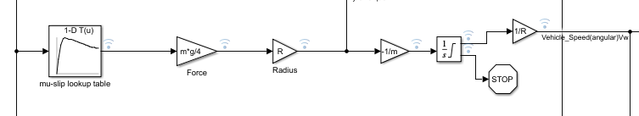

Tyre torque is multiplied by -1/m and then integrated to get the vehicle linear velocity. The negative sign denotes deceleration and multiplied by 1/R to get vehicles angular velocity.

## Calculation of Actual Relative slip

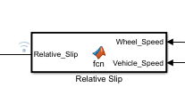

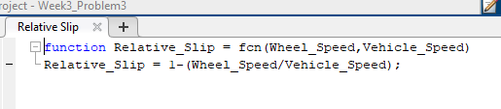

To get the Actual Relative Slip we subtract 1 from the result obtained by dividing wheel speed with vehicle speed we used the Matlab function block for this expression.

## Friction-Slip lookup table

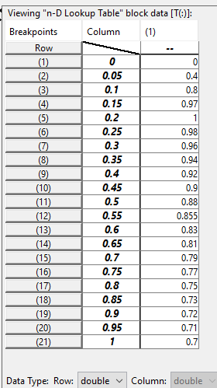

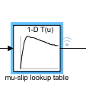

To get the slip for various coefficients of friction I have used 1-D lookup table to get the desired value.

## Desired input Slip

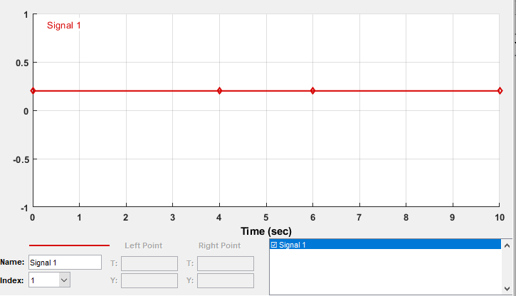

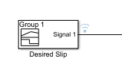

Desired input slip is given from the signal builder which in this case is 0.2.

## Solver Selection

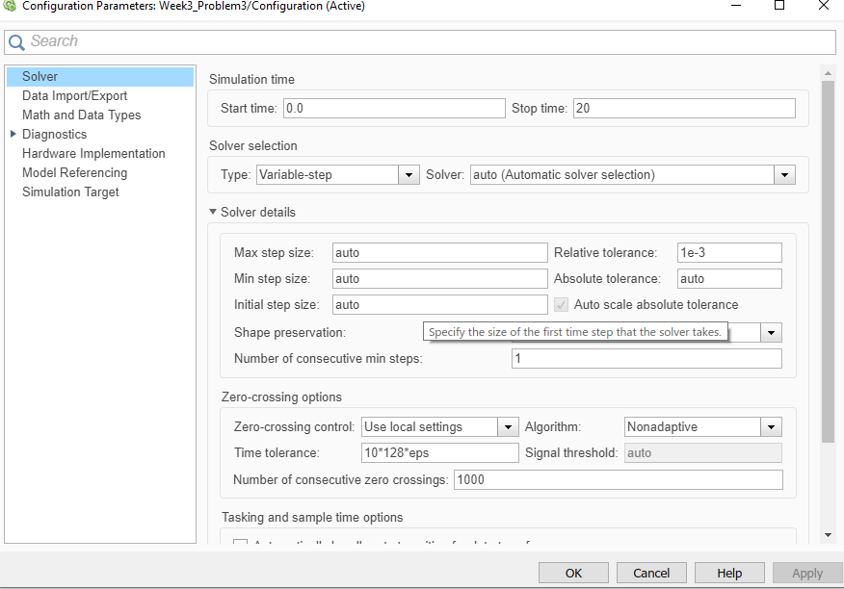

Solver is set to variable step and auto with a stop time of 20 for the model used.

## Use of Callbacks

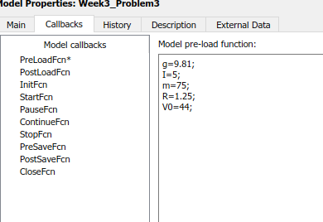

Callbacks are used to pre load the values of the variables used in the model as shown in the figure above.

## Visualising the output using data inspector

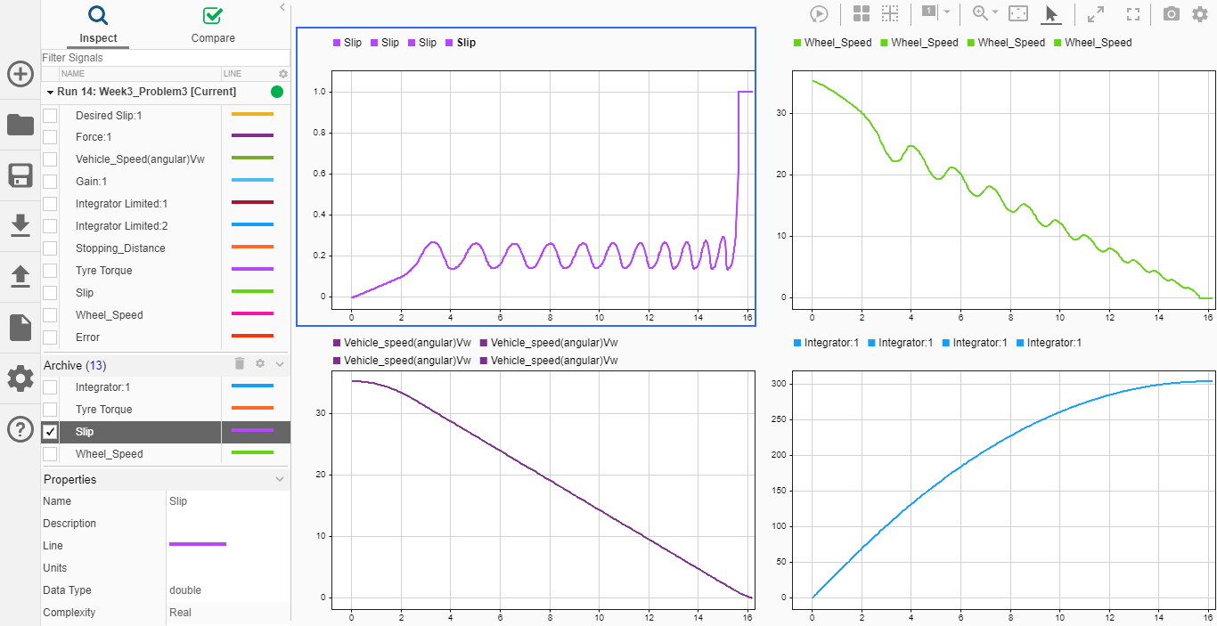

Data inspector is used to view signal lines at various stages of development, in the above figure we can see graph for slip, wheel speed, vehicle speed and stopping distance of the vehicle.

## Conclusion

This model shows how you can use Simulink to simulate a braking system under the action of an Anti-Lock Breaking System. We can also simulate the model to see vehicle speed, wheel speed, stopping distance and Actual Relative slip. Further we can also use Data inspector to view the characteristics of different signal lines.